**Nested Repetition Task:**

Task 1 (A):  
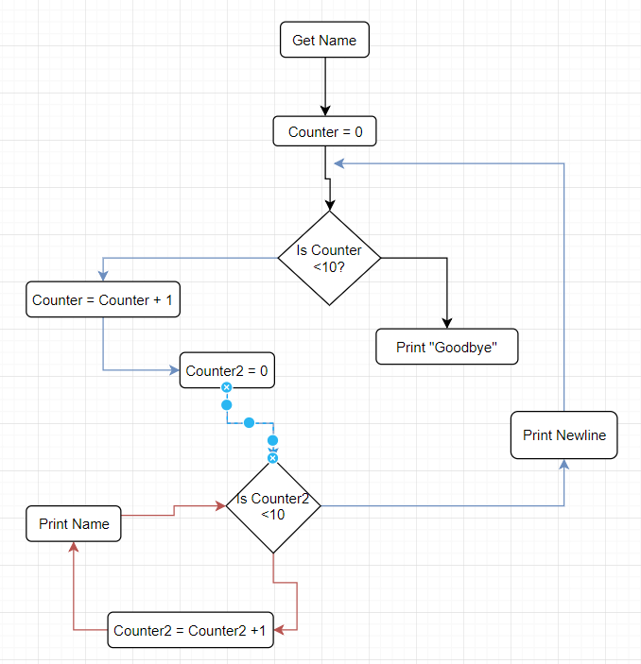  
  
  
  
  
  
  
  
Pseudocode:  
 Get Name  
 Counter = 0  
 While (Counter <10) {  
 Counter += 1  
 Counter2= 0  
 While (Counter2 <10){  
 Counter2 += 1  
 Print Name  
 }  
 Print Newline  
 }  
 Print Goodbye  
  
  
  
  
  
  
  
  
  
  
  
  
  
  
  
  
Task 1 (B):  
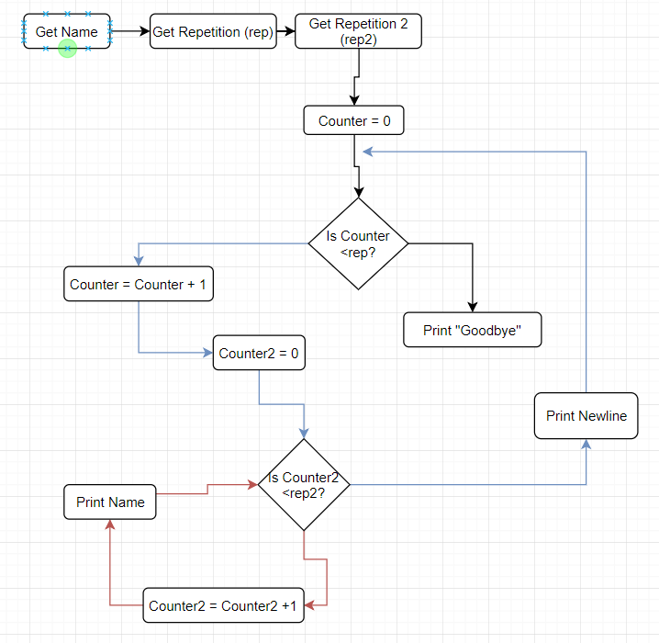  
  
  
  
  
  
  
  
  
  
  
Pseudocode:  
 Get Name  
 Get Repetition (rep)  
 Get Repetition 2 (rep 2)  
 Counter = 0  
 While (Counter <rep) {  
 Counter += 1;  
 Counter2 = 0  
 While (Counter2 < rep2) {  
 Counter2 += 1;  
 Print Name;  
 }  
 Print Newline  
 }  
 Print Goodbye